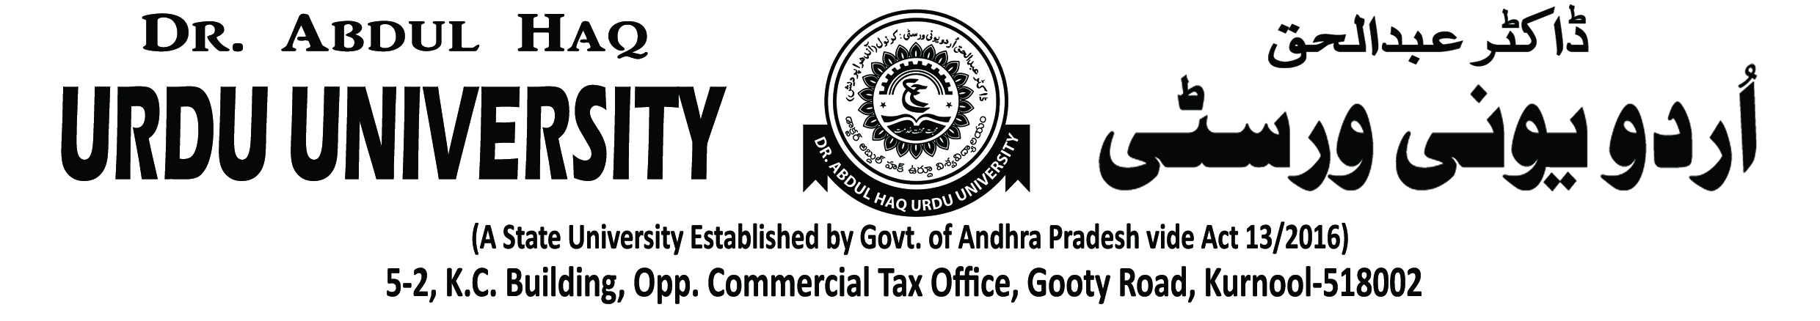

Dr. Abdul Haq Urdu University NSS UNIT

NSS Volunteers active participated in Golden Jubilee NSS day programme in University Campus on 24-09-2019.Apart this programme our Vice-Chancellor and NSS Volunteers participate in Plantation and Motivation students about the NSS scheme. In this programme Honourable Vice-Chancellor Prof K. Muzaffer Ali, NSS Co-ordinator Dr. S Mahaboob Basha, University in-charge Principal Md. Irfan, Faculty Members and Students are also participated.

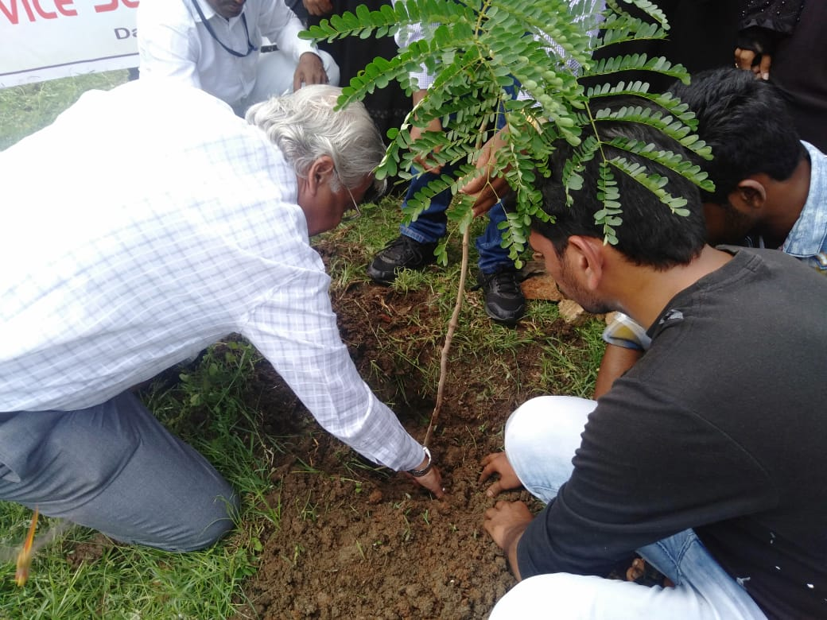 | 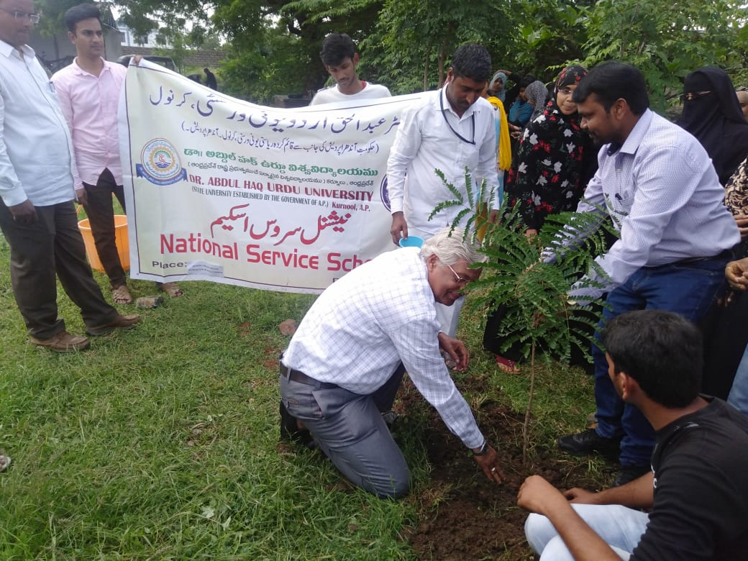
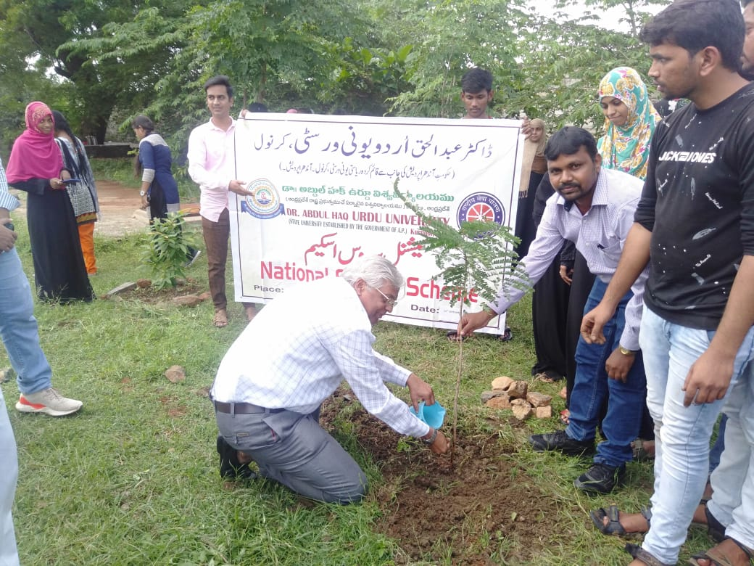 | 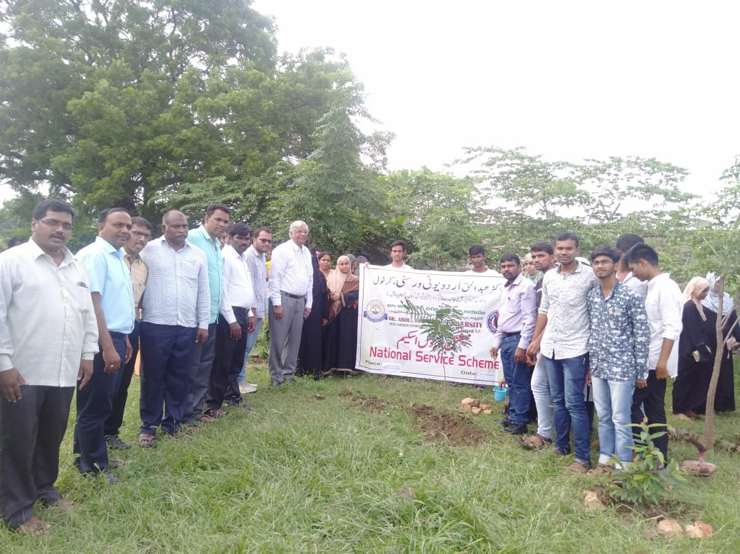
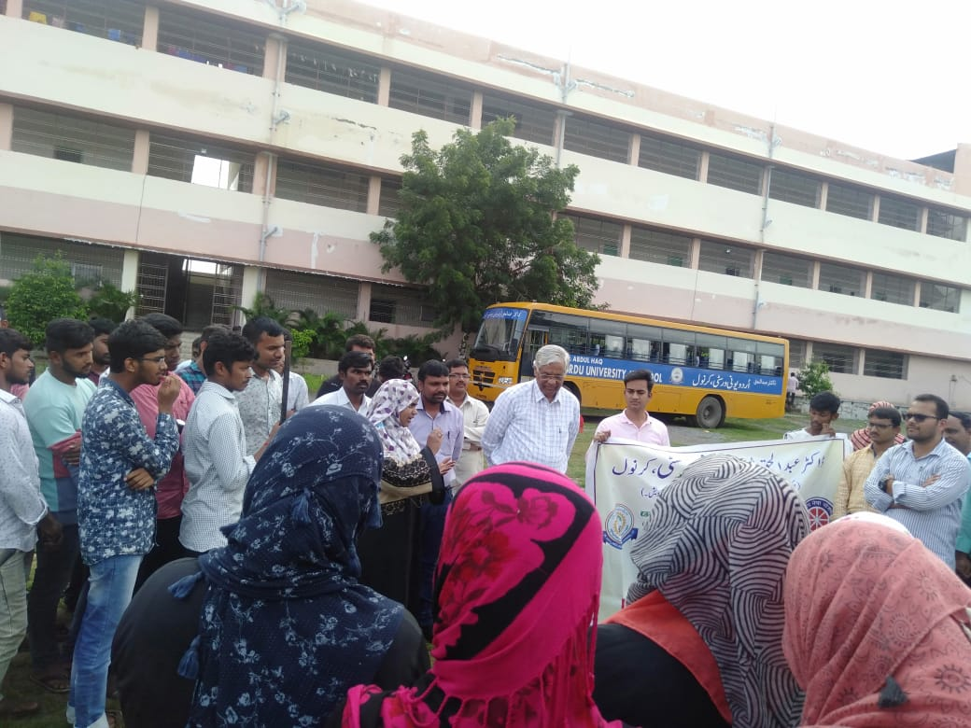 | 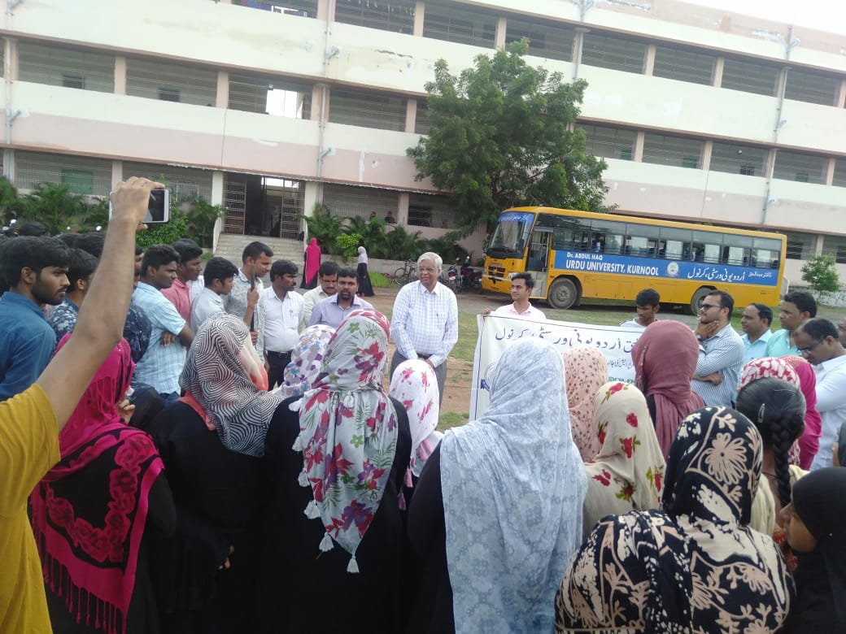

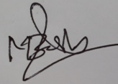

NSS Co-ordinator
(Dr. S.Mahaboob Basha)

